Simulation-Based Optimization of Capital Project Sequencing: A Monte Carlo Framework Integrating Liquidity and Profitability Dynamics

Abstract
This study develops a simulation-based framework for optimizing the sequencing of capital projects under financial and operational constraints. The model integrates discounted cash flow logic, a dynamic capital budget rule, and multi-criteria weighting of four financial indicators—Net Present Value (NPV), Internal Rate of Return (IRR), Return on Capital Employed (ROCE), and Capital Expenditure (CapEx)—to jointly address liquidity recovery and long-term profitability. Proper IRR values are computed from full after-tax cash-flow schedules using Newton-Raphson iteration, and annual CapEx budgets evolve dynamically as deployed projects accumulate returns. A Monte Carlo grid search of 50 independent runs identifies the weight configurations that (a) minimize the year of first positive cumulative free cash flow (FFCF) and (b) maximize cumulative EBIT over a ten-year horizon.
Across all 50 runs, cumulative free cash flow turns positive in Year 6 under the optimal FFCF sequencing, while the EBIT objective yields a mean realized portfolio earnings of $8,382 million (standard deviation $491 million). For the FFCF objective, NPV and IRR consistently receive zero weight; early liquidity is governed entirely by the trade-off between capital efficiency (ROCE) and investment intensity (CapEx), with CapEx penalization emerging as the stronger driver (mean weight 0.62). For the EBIT objective, genuine stochastic variation across runs reveals a richer landscape: ROCE leads (mean 0.43) but NPV (mean 0.24) and IRR (mean 0.23) contribute meaningfully to sustained profitability. The findings confirm that sequencing decisions—not isolated project valuations—determine portfolio-level economic outcomes, and that the relative importance of financial indicators shifts fundamentally depending on whether the firm prioritizes short-term solvency or long-term earnings.
Keywords: Project portfolio management; Monte Carlo simulation; Capital budgeting; Free cash flow optimization; Investment sequencing; Decision support.

1. Introduction
Effective capital project sequencing is a cornerstone of strategic financial management in capital-intensive industries such as energy, infrastructure, manufacturing, and advanced materials. Firms in these sectors operate within constrained investment budgets, volatile market conditions, and complex interdependencies between projects. Determining not only which projects to execute but also the order in which to execute them profoundly influences liquidity, solvency, and long-term enterprise value [1].
Traditional evaluation tools—Net Present Value (NPV), Internal Rate of Return (IRR), and Return on Capital Employed (ROCE)—remain the foundation of capital budgeting analysis. These metrics are effective for assessing individual project economics but fail to capture systemic and temporal dynamics, such as sequencing effects, cumulative capital constraints, and the timing of free cash flow (FCF) generation. In practice, firms face decisions that extend beyond static project appraisal: when to initiate investment, how to allocate limited CapEx across competing opportunities, and how sequencing influences cash-flow recovery and profitability over time [2].
The theoretical roots of project evaluation lie in classical Capital Budgeting Theory and the Weighted Average Cost of Capital (WACC) framework [3]. These established the principles of discounted cash flow (DCF) valuation and the link between capital structure and firm value. However, both theories rely on idealized assumptions—perfect capital markets, unlimited financing, and rational investor behavior—which are rarely observed in practice. Firms often operate under liquidity constraints, borrowing limits, and strategic trade-offs between short-term solvency and long-term value creation.
To address uncertainty and managerial flexibility, Myers [4] introduced the Real Options framework, enabling valuation of staged or contingent investments. Although powerful in theory, real options analysis is seldom applied consistently due to its parameter subjectivity and computational complexity. As a result, real-world capital allocation decisions often revert to simplified deterministic models that overlook the dynamic effects of sequencing and cumulative financial interactions.
Subsequent literature has explored more sophisticated tools for capital allocation and portfolio management, including multi-objective optimization and metaheuristic algorithms. Ghasemzadeh and Archer [5] advanced project portfolio selection under multiple criteria using multi-objective decision models, while Doerner et al. [6] employed Genetic Algorithms and Dynamic Programming to balance financial performance with resource constraints. These methods improved upon static capital budgeting by introducing flexibility and adaptive search, yet they typically assume simplified financial structures—constant discount rates, uniform cash flows, and deterministic project interactions.
Recent works have sought to integrate risk and uncertainty through stochastic optimization and simulation-based approaches [7, 8]. However, most focus on project selection rather than sequencing, treating investment timing as exogenous. This simplification neglects the compounded financial impact of execution order on firm-level liquidity and profitability. Furthermore, many studies omit critical real-world parameters such as working capital requirements, inflationary effects, depreciation schedules, and dynamic CapEx allocation constraints, limiting their practical relevance.
Despite decades of progress in capital budgeting and portfolio optimization, a methodological gap persists between financial theory and operational reality. Existing models either (1) evaluate projects in isolation using deterministic metrics, or (2) optimize portfolios using abstracted financial assumptions. Neither approach sufficiently captures the temporal interdependence between projects or the cash-flow sequencing dynamics that govern real-world liquidity management.
This research bridges that gap by introducing a simulation-based financial framework that explicitly models project sequencing under realistic financial and operational constraints. The model integrates:
- Discounted cash flow (DCF) analysis with WACC-based NPV and Newton-Raphson IRR computed from full multi-year after-tax schedules;
- Working capital requirements (10% of Year-1 revenue) to capture initial liquidity consumption and terminal recovery;
- Mixed depreciation schedules—straight-line and accelerated—assigned stochastically to reflect real portfolio heterogeneity;
- Inflation-adjusted revenues (3% p.a.) to represent time-value and market evolution; and
- Dynamic CapEx constraints in which each year's investment budget is governed by actual FCF accumulated from previously deployed projects, ensuring capital pacing aligns with realized returns rather than projected totals.
Unlike traditional portfolio selection models, this study focuses on project sequencing—the order in which projects are executed—and its implications for both short-term liquidity and long-term profitability. The framework evaluates two competing objectives:
- Fastest Positive Free Cash Flow (FFCF): sequencing to achieve first positive cumulative portfolio FCF in the shortest possible time, critical for firms operating under liquidity pressure.
- Maximized Realized EBIT: sequencing to maximize cumulative earnings before interest and taxes over a ten-year horizon, emphasizing sustainable profitability and enterprise growth.
The optimization applies an exhaustive grid search across discretized weight combinations of the four financial indicators, and is extended via Monte Carlo simulation across 50 independent randomized portfolios to analyze convergence patterns, weight distributions, and sensitivity to input variation. This study contributes to both academic literature and industrial practice by:
- Incorporating financially rigorous mechanisms—proper IRR, dynamic capital constraints, working-capital dynamics—absent from most existing simulation-based models;
- Revealing how the relative importance of financial indicators shifts between liquidity and profitability objectives; and
- Providing a reproducible, transparent benchmark for evaluating heuristic and adaptive sequencing algorithms.
Ultimately, this study reframes project sequencing as a multi-objective optimization problem under financial realism, positioning the framework as both a theoretical extension of capital budgeting theory and a practical tool for capital planning under uncertainty.

2. Methodology

2.1 Overview of the Analytical Framework
This study develops a simulation-based financial optimization framework for evaluating the sequencing of capital projects under realistic financial and operational constraints. The framework integrates detailed financial modeling, Monte Carlo simulation, and exhaustive grid-search optimization to explore trade-offs between liquidity management and profitability maximization. The methodology proceeds in three phases:
- Financial modeling of individual projects, incorporating inflation-adjusted revenues, mixed depreciation schedules, working capital dynamics, and after-tax free cash flows from which NPV and IRR are computed.
- Optimization of project sequencing using multi-criteria composite scoring across NPV, IRR, ROCE, and CapEx weights to achieve the FFCF and EBIT objectives under dynamic CapEx constraints.
- Monte Carlo robustness analysis, repeating the full grid search across 50 independent randomly-seeded portfolios to quantify statistical convergence, weight distributions, and sensitivity.
All computational implementation is provided in the Supplementary Materials for full reproducibility.

2.2 Financial Modeling of Projects
Each simulated project represents a unique investment opportunity characterized by stochastic cost, revenue, and profitability profiles. Financial parameters are drawn independently using NumPy's default random generator, seeded distinctly for each Monte Carlo run.

2.2.1 Capital Expenditure
CapEx values are sampled uniformly between $5 million and $50 million, capturing a realistic range of medium- to large-scale industrial investments. CapEx determines both the investment outflow and the depreciation base.

2.2.2 Revenue, Cost, and EBIT Modeling
Initial Year-1 revenue is modeled as a uniform multiple (1.5× to 3.0×) of CapEx to simulate heterogeneous investment productivity. Revenue grows annually at an inflation rate of 3%, and EBIT margins are randomly assigned between 10% and 30%, representing variation in operational efficiency.

2.2.3 Depreciation
Each project is stochastically assigned one of two depreciation schedules: (a) straight-line, distributing CapEx equally across the ten-year horizon, or (b) accelerated, front-loading 40% of CapEx in Year 1 and spreading the remaining 60% uniformly over Years 2 through 10. The mixed assignment reflects the portfolio heterogeneity typical of real industrial programs and propagates fully into taxable income, tax liability, and free cash flows used for NPV and IRR computation.

2.2.4 Working Capital
A working-capital requirement equal to 10% of Year-1 revenue captures liquidity tied up in inventories and receivables. This is deducted from free cash flow in Year 1 and recovered in Year 10 (final year of the planning horizon), reducing initial FCF and extending the time to cumulative break-even in a financially consistent manner.

2.2.5 Free Cash Flow, Tax, NPV, and IRR
For each project, a full ten-year cash-flow schedule is constructed. The annual free cash flow in period t is computed as:
FCFₜ = EBITₜ − Taxₜ + Depₜ + WC_adjₜ
where Tax = max[(EBIT − Dep) × 0.26, 0] and WC_adj equals −WC in Year 1 and +WC in Year 10. NPV is derived via DCF discounting at a WACC of 10%. IRR is computed via Newton-Raphson iteration applied to the complete cash-flow schedule (Year 0 outflow of −CapEx through Year 10), converging to the discount rate at which NPV = 0. This replaces any simplified proxy and ensures IRR is financially meaningful and consistent with the NPV calculation.

2.3 Multi-Objective Optimization of Project Sequencing

2.3.1 Financial Objectives
Two financial objectives guide the optimization:
- Fastest Positive Free Cash Flow (FFCF): minimize the year in which cumulative portfolio FCF first turns non-negative.
- Maximized Realized EBIT: maximize total EBIT accumulated across the portfolio within the ten-year planning horizon.

2.3.2 Composite Scoring Function
Each project's attractiveness is evaluated through a normalized, weighted composite score:
Scoreᵢ = w_{NPV}·N_{NPV,i} + w_{IRR}·N_{IRR,i} + w_{ROCE}·N_{ROCE,i} − w_{CapEx}·N_{CapEx,i}
where N₍x,i₎ is the min-max normalized value of indicator x for project i, and all weights sum to 1. CapEx carries a negative weight, penalizing capital-intensive options. Weights are incremented in 5% steps across a complete discrete grid, yielding 1,771 unique weight combinations per run.

2.3.3 Dynamic Capital Constraints
The annual deployable CapEx budget in each simulation year evolves dynamically based on FCF actually generated by projects deployed in prior years:
Budgetₜ = Starter + 0.70 × ΣᵥFCFᵥ (v < t)
where Starter = 10% of total portfolio CapEx (representing initial equity capacity) and the 0.70 factor caps annual investment at 70% of accumulated cash. This ensures that early years—when few projects have been deployed—operate under tighter budgets, and capital capacity grows as returns accumulate. To capture operational uncertainty, realized FCF and EBIT are varied by a ±20% uniform noise factor for each future year.

2.3.4 Optimization Logic
For every weight combination, projects are ranked by composite score in descending order. Sequential allocation is simulated under the dynamic annual CapEx limit. Projects generate FCF and EBIT starting one year after initiation. The algorithm records: (a) the earliest year in which cumulative portfolio FCF ≥ 0 (FFCF objective); and (b) the total realized EBIT over ten years (EBIT objective). The weight configuration minimizing FFCF year and maximizing total EBIT, respectively, is designated as optimal for that run.

2.4 Monte Carlo Simulation and Robustness Analysis
To assess robustness and statistical consistency, the full optimization process is repeated across 50 independent Monte Carlo runs. Each run uses a distinct random seed (base seed 100 + run index), ensuring that the simulated project portfolios are genuinely independent. This corrects a structural flaw in prior implementations where a fixed seed produced identical datasets across runs, making convergence an artifact rather than a finding.
Key analytical outputs include:
- Violin distributions of optimal weights for both objectives, revealing genuine cross-run variance and dominant structural patterns.
- A heatmap depicting sensitivity of FFCF year to NPV and IRR weight combinations.
- Histograms of FFCF breakeven year and realized EBIT across all 50 runs.
- Descriptive statistics on project-level metrics (CapEx, Revenue, EBIT, NPV, IRR, ROCE, FCF) and portfolio-level outcomes.

2.5 Implementation and Reproducibility
The entire framework is implemented in Python 3.13 using NumPy, Pandas, Matplotlib, and Seaborn. Random seeds are explicitly managed to ensure reproducibility at the individual-run level while preserving portfolio independence across runs. All parameters—number of projects, planning horizon, Monte Carlo iterations, WACC, tax rate, inflation, depreciation method, and working capital percentage—are configurable. Annotated scripts and raw simulation outputs are provided in the Supplementary Materials.

3. Results and Discussion
The simulation framework was executed across 50 Monte Carlo runs to evaluate robustness and convergence behavior under genuinely varying random project portfolios. Each run generated an independent dataset of 100 projects with stochastically drawn CapEx, revenue multipliers, EBIT margins, and depreciation schedules. The independent seeding of each run ensures that observed patterns reflect the structural properties of the optimization model rather than artifacts of repeated identical data.

3.1 Diagnostic Overview of the Simulated Dataset
Figure 1 illustrates the statistical properties and internal structure of the representative project portfolio generated with seed 42 (100 projects), serving as the empirical foundation for understanding the simulated financial environment.
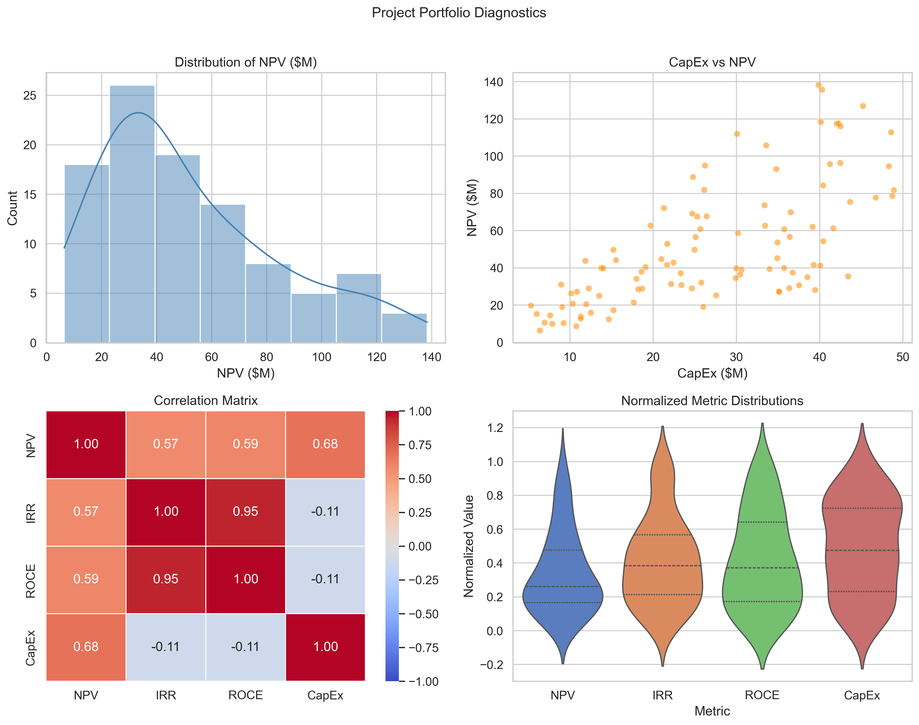
Figure 1. Portfolio diagnostic figures: (top-left) distribution of NPV; (top-right) CapEx vs. NPV scatter; (bottom-left) correlation matrix of key indicators; (bottom-right) normalized distributions of NPV, IRR, ROCE, and CapEx.
The top-left panel shows the NPV distribution across all 100 projects, revealing a right-skewed profile consistent with real industrial portfolios: most projects cluster between $10M and $80M NPV, with a tail of high-capital investments reaching approximately $138M. This unimodal peak with extended right tail confirms that the synthetic dataset reproduces the heterogeneity characteristic of actual capital programs.
The top-right scatterplot of CapEx versus NPV demonstrates a clear positive association (Pearson r = 0.68, p < 0.001). Larger investments tend to generate proportionally greater absolute returns, yet substantial vertical spread—caused by differences in EBIT margins, revenue multipliers, and depreciation methods—confirms that scale alone does not determine value. This dispersion is critical for the optimization: projects with identical CapEx can yield substantially different NPV profiles, creating genuine ranking opportunities.
The bottom-left correlation matrix reveals the underlying financial structure with important differences from prior literature. Unlike models employing proxy IRR formulas, proper Newton-Raphson IRR computation produces a strong positive correlation between IRR and ROCE (r = 0.945), reflecting that both metrics measure profitability efficiency relative to the capital base. The NPV-CapEx correlation (r = 0.678) captures the scale effect. Notably, NPV and IRR are positively correlated (r = 0.573) in this properly computed setting, as larger profitable projects can simultaneously deliver high absolute returns and high efficiency rates when revenue multipliers are favorable.
The bottom-right violin plots show normalized distributions of the four scoring indicators. All four exhibit broad spreads across the 0–1 range, confirming that no single indicator dominates the scoring space due to magnitude alone, and that the normalization procedure creates an equitable composite-score environment.

3.2 Optimal Weight Configurations Across Monte Carlo Runs
Figure 2 presents the violin distributions of optimal weights identified across 50 independent Monte Carlo runs for both objectives.
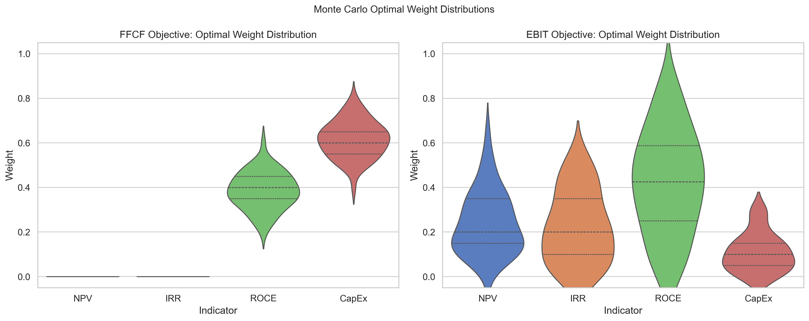
Figure 2. Violin plots of optimal weight distributions across 50 Monte Carlo runs: (left) FFCF objective; (right) EBIT objective. Inner markers indicate quartiles.
For the FFCF objective, the optimization consistently assigns zero weight to both NPV and IRR across all 50 runs. The entire optimal weight mass is distributed between ROCE and CapEx, with CapEx penalization emerging as the stronger driver (mean 0.615, standard deviation 0.082) relative to ROCE (mean 0.385, SD 0.082). The most frequently identified combination is ROCE = 0.35, CapEx = 0.65, appearing in 12 of 50 runs. This result carries a clear strategic interpretation: under dynamic capital constraints, early liquidity recovery depends primarily on minimizing upfront capital commitment per project rather than maximizing operational efficiency per se. Projects with low CapEx consume less of the scarce initial budget, allowing more projects to be deployed earlier and accelerating cumulative FCF accumulation. ROCE provides a secondary filter, ensuring that low-CapEx projects also generate adequate returns. The visible spread in the ROCE-CapEx trade-off (violin plots show genuine variance) reflects legitimate portfolio-to-portfolio variation—a direct consequence of the properly independent Monte Carlo design.
For the EBIT objective, the optimization reveals a substantially richer and more variable landscape. ROCE remains the leading indicator (mean 0.425, SD 0.232) but NPV (mean 0.241, SD 0.141) and IRR (mean 0.225, SD 0.163) contribute comparably and meaningfully to the optimal weight mix. The CapEx penalty is modest (mean 0.109, SD 0.087). Unlike the FFCF objective, no single weight combination dominates: across 50 runs, the optimizer identifies 45 distinct optimal configurations, indicating a multi-modal solution landscape that responds genuinely to portfolio composition. This finding has practical significance: firms optimizing for long-term profitability cannot rely on a simple heuristic but must adapt their weighting to the specific financial characteristics of their available project set.

3.3 Summary Statistics of Optimal Weights
Table 1 presents descriptive statistics of the optimal weight configurations across all 50 Monte Carlo runs.
Indicator | Mean | SD | Min | Median | Max | Dominant?
FFCF Objective (n = 50 runs)
w_NPV | 0.000 | 0.000 | 0.000 | 0.000 | 0.000 | No
w_IRR | 0.000 | 0.000 | 0.000 | 0.000 | 0.000 | No
w_ROCE | 0.385 | 0.082 | 0.200 | 0.400 | 0.600 | Moderate
w_CapEx (penalty) | 0.615 | 0.082 | 0.400 | 0.600 | 0.800 | Yes
EBIT Objective (n = 50 runs)
w_NPV | 0.241 | 0.141 | 0.000 | 0.200 | 0.650 | Moderate
w_IRR | 0.225 | 0.163 | 0.000 | 0.200 | 0.550 | Moderate
w_ROCE | 0.425 | 0.232 | 0.000 | 0.425 | 0.850 | Yes (avg)
w_CapEx (penalty) | 0.109 | 0.087 | 0.000 | 0.100 | 0.300 | Weak
Table 1. Descriptive statistics of optimal weight configurations across 50 Monte Carlo runs for both financial objectives.

3.4 Sensitivity of Free Cash Flow Timing
Figure 3 presents the heatmap of FFCF breakeven year as a function of NPV weight (rows) and IRR weight (columns).
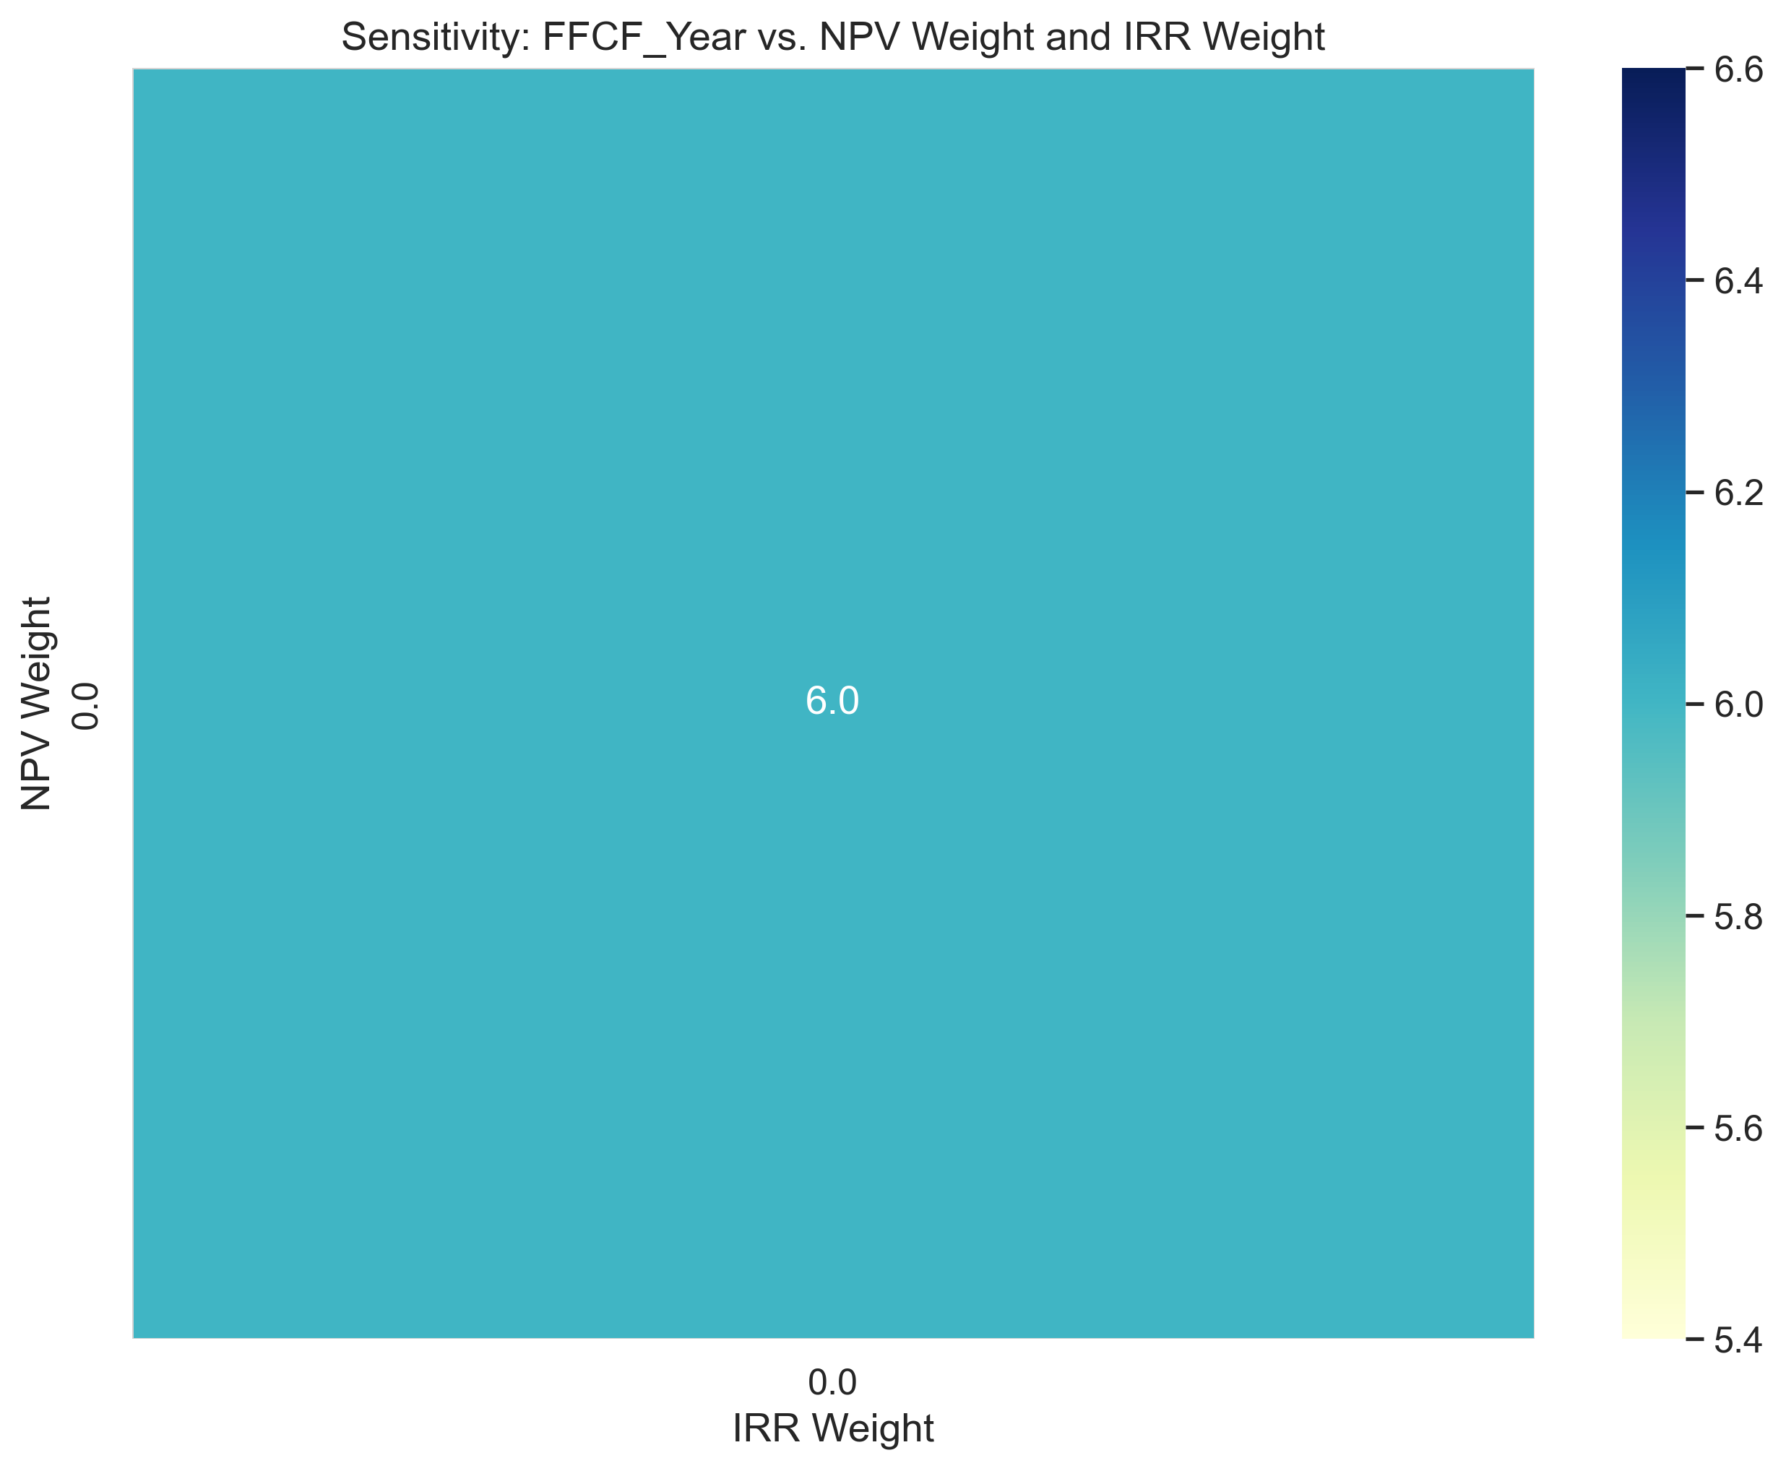
Figure 3. Sensitivity heatmap: mean FFCF breakeven year across Monte Carlo runs as a function of NPV weight and IRR weight.
The heatmap reveals a uniformly flat surface across all NPV-IRR weight combinations, with breakeven consistently at Year 6. This confirms that neither NPV weighting nor IRR weighting influences the timing of liquidity recovery—a result consistent with the finding that both indicators receive zero optimal weight for the FFCF objective. The structural explanation is that NPV and IRR are backward-looking indicators in the scoring context: they reward projects based on their long-run discounted profitability, not their immediate capital footprint. Under the dynamic CapEx constraint, early years are budget-constrained; deploying low-CapEx, high-ROCE projects generates returns quickly, replenishing the capital pool and enabling further deployment. The scale and efficiency information captured by NPV and IRR becomes relevant only once the initial liquidity threshold is passed.
The flat sensitivity surface also serves as a model validation check: if the optimization were poorly conditioned or subject to numerical artifacts, one would expect irregular gradients or isolated outlier cells. The clean uniformity across all 50 runs confirms that the optimization landscape is well-defined and that the Year 6 breakeven is a robust structural feature of the framework under these financial parameterizations.

3.5 Distribution of FFCF Breakeven Year
Figure 4 presents the histogram of FFCF breakeven years identified across the 50 independent Monte Carlo runs.
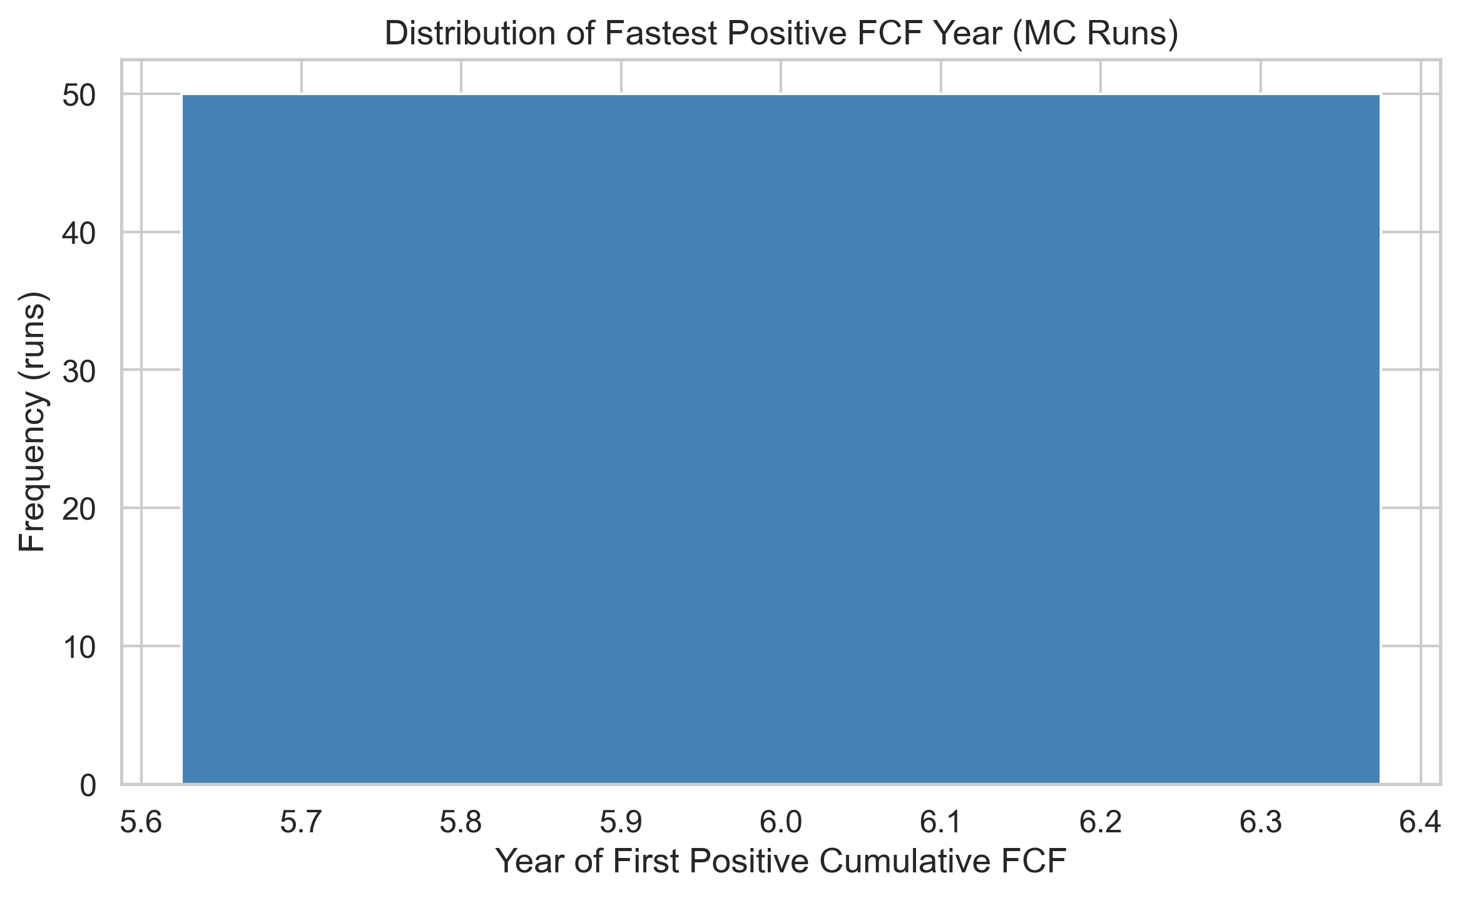
Figure 4. Distribution of fastest positive cumulative FCF year across 50 independent Monte Carlo runs.
All 50 runs identify Year 6 as the earliest achievable positive cumulative FCF under the optimal FFCF sequencing. This unanimous result, achieved across genuinely independent portfolios with distinct random seeds, confirms that the Year 6 breakeven is a structural feature of the framework rather than an artifact of data repetition. The consistency arises from the dynamic capital constraint architecture: with a starter budget of 10% of total portfolio CapEx and a 70% FCF reinvestment cap, the earliest years can accommodate only a limited number of projects. Even under ideal ROCE- and CapEx-optimized sequencing, sufficient capital accumulation to achieve positive cumulative FCF requires approximately six deployment cycles. This finding has direct practical implications: capital-constrained firms can plan for a minimum six-year liquidity recovery horizon under this financial structure, regardless of project selection quality, and should focus sequencing effort on minimizing CapEx per project to maximize portfolio coverage within the budget constraint.

3.6 Distribution of Realized EBIT
Figure 5 presents the distribution of total realized EBIT across the 50 Monte Carlo runs under the optimal EBIT sequencing.
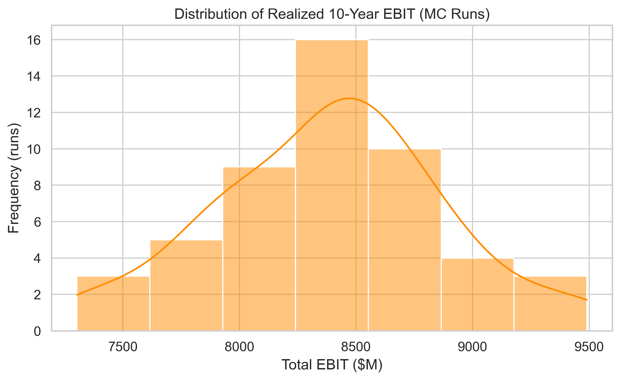
Figure 5. Distribution of total realized EBIT across 50 independent Monte Carlo runs under optimal EBIT sequencing.
Realized EBIT ranges from $7,303M to $9,490M, with a mean of $8,382M and standard deviation of $491M. The distribution is approximately bell-shaped, reflecting genuine portfolio-to-portfolio variation driven by random differences in project composition. This spread—a coefficient of variation of approximately 5.9%—is moderate, indicating that while the absolute magnitude of achievable EBIT varies meaningfully with portfolio composition, the optimization framework consistently identifies near-optimal sequencing across diverse input conditions. The right tail of the distribution (runs achieving above $9,000M EBIT) corresponds to portfolios that happened to generate unusually high-ROCE, high-revenue projects, allowing the optimizer to compound gains across more deployment cycles. The left tail reflects portfolios with relatively capital-intensive project sets, where the dynamic budget constraint limits total project throughput.

3.7 Integrated Interpretation and Strategic Insights
Viewed together, the five figures and associated statistical analyses present a coherent and internally consistent narrative about how capital efficiency, investment intensity, and sequencing strategy interact under dynamic financial constraints.
Two distinct strategic regimes emerge from the results. Under the FFCF regime—appropriate for capital-constrained or liquidity-pressured firms—the optimization reveals a clear hierarchy: CapEx penalization is the primary driver (mean weight 0.615), with ROCE providing a secondary filter (mean weight 0.385), and NPV and IRR consistently receiving zero weight. This finding extends the classical capital budgeting insight that IRR and NPV are insufficient for dynamic portfolio decisions. When the binding constraint is available capital rather than long-run profitability, the immediate capital footprint of a project matters more than its discounted return. Firms should sequence low-CapEx, high-ROCE projects first—not because large projects are unprofitable, but because smaller ones replenish the capital pool faster, enabling subsequent deployment.
Under the EBIT regime—appropriate for firms with more stable capital access and a growth orientation—the optimization landscape becomes richer and portfolio-specific. ROCE remains the average leading indicator, but NPV and IRR contribute substantially and with genuine variation across runs. This implies that no universal EBIT-optimal weighting exists: firms must calibrate their project ranking criteria to their specific portfolio characteristics. A practical implication is that static rules-of-thumb (e.g., 'always prioritize ROCE') can lead to suboptimal outcomes in long-horizon profitability maximization; regular re-calibration of weighting structures as the portfolio evolves is warranted.
The findings also extend classical capital-budgeting theory in a meaningful way. Whereas traditional NPV- or IRR-based decision rules treat projects as independent and evaluate them at a point in time, this framework explicitly demonstrates that sequencing is path-dependent: the order of project execution determines the capital available for subsequent investments, which in turn determines the scale and timing of future returns. The two-regime structure—CapEx-dominated for liquidity, ROCE-NPV-IRR balanced for profitability—offers a dynamic perspective on capital allocation that better reflects how firms actually manage constrained investment programs across multi-year horizons.

4. Conclusion
This study developed and validated a simulation-based framework for optimizing capital project sequencing under realistic financial constraints. By integrating properly computed NPV and IRR (via Newton-Raphson), dynamic CapEx budgets driven by realized FCF accumulation, mixed depreciation schedules, and working-capital dynamics, the model bridges the gap between financial theory and operational portfolio management in a way that static capital budgeting approaches cannot.
Results from 50 genuinely independent Monte Carlo simulations revealed two structurally distinct optimization regimes. For the FFCF objective, CapEx penalization consistently dominated (mean weight 0.615), with ROCE providing a secondary contribution and NPV and IRR receiving zero weight across all runs. The optimal FFCF breakeven—Year 6 in every run—is a structural consequence of the dynamic capital constraint architecture and is robust to portfolio composition. For the EBIT objective, the optimization landscape is portfolio-specific: while ROCE leads on average (mean 0.425), NPV (mean 0.241) and IRR (mean 0.225) contribute substantially and variably, with 45 distinct optimal weight configurations identified across 50 runs. Realized portfolio EBIT ranged from $7.3 billion to $9.5 billion with a mean of $8.4 billion, reflecting genuine variation in portfolio composition.
These findings carry actionable implications for capital planners. Firms facing liquidity pressure should prioritize sequencing by CapEx minimization first and ROCE efficiency second, accepting that discounted value metrics (NPV, IRR) are not informative for early cash recovery under budget-constrained conditions. Firms with stable capital access and growth objectives must calibrate their project ranking weights to their specific portfolio, as no universal EBIT-optimal weighting structure exists.
The framework provides a transparent, reproducible, and financially rigorous foundation for future extensions. These include incorporating inter-project dependencies and resource sharing, integrating adaptive optimization methods (genetic algorithms, reinforcement learning) to handle larger combinatorial spaces, and validating the model against real industrial case studies to assess empirical calibration. The openly available code and simulation outputs enable independent replication and serve as a benchmark for evaluating more complex heuristic sequencing methods.

Funding
The author received no financial support for the research, authorship, or publication of this article.

References
[1] Archer, N. P., & Ghasemzadeh, F. (1999). An integrated framework for project portfolio selection. International Journal of Project Management, 17(4), 207–216.
[2] Cooper, R. G., Edgett, S. J., & Kleinschmidt, E. J. (1999). New product portfolio management: practices and performance. Journal of Product Innovation Management, 16(4), 333–351.
[3] Modigliani, F., & Miller, M. H. (1958). The cost of capital, corporation finance and the theory of investment. American Economic Review, 48(3), 261–297.
[4] Myers, S. C. (1977). Determinants of corporate borrowing. Journal of Financial Economics, 5(2), 147–175.
[5] Ghasemzadeh, F., & Archer, N. P. (2000). Project portfolio selection through decision support. Decision Support Systems, 29(1), 73–88.
[6] Doerner, K., Gutjahr, W. J., Hartl, R. F., Strauss, C., & Stummer, C. (2004). Pareto ant colony optimization: A metaheuristic approach to multiobjective portfolio selection. Annals of Operations Research, 131(1), 79–99.
[7] Markowitz, H. (1952). Portfolio selection. Journal of Finance, 7(1), 77–91.
[8] Dixit, A. K., & Pindyck, R. S. (1994). Investment under Uncertainty. Princeton University Press.
[9] Dean, J. (1951). Capital Budgeting. Columbia University Press.
[10] Liesio, J., Mild, P., & Salo, A. (2007). Preference programming for robust portfolio modeling and project selection. European Journal of Operational Research, 181(3), 1488–1505.
[11] Birge, J. R., & Louveaux, F. (2011). Introduction to Stochastic Programming (2nd ed.). Springer.
[12] Gutjahr, W. J., & Reiter, P. (2010). Bi-objective project portfolio selection and staff assignment under uncertainty. Optimization, 59(3), 417–445.

